**Association Rules**

**Example-My Movies Dataset**

**Based on Apriori algorithm with support 0.005 and confidence 0.05 and minimum length as 3 we are getting 77 rules.**

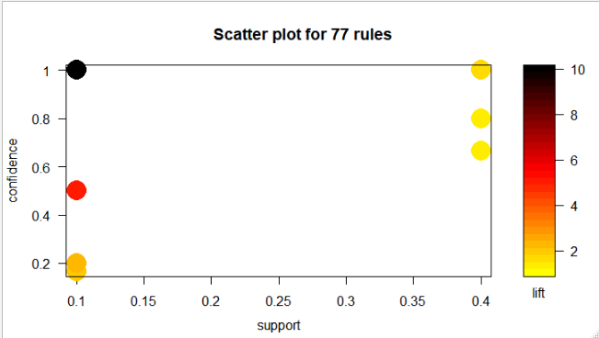

|  |
| --- |
| **> inspect(head(sort(Mrules, by = "lift")))**  lhs rhs support confidence lift count  [1] {Gladiator,Green.Mile} => {LOTR} 0.1 1.0 10 1  [2] {Sixth.Sense,Gladiator,Green.Mile} => {LOTR} 0.1 1.0 10 1  [3] {Gladiator,LOTR} => {Green.Mile} 0.1 1.0 5 1  [4] {Sixth.Sense,LOTR} => {Green.Mile} 0.1 1.0 5 1  [5] {Sixth.Sense,Green.Mile} => {LOTR} 0.1 0.5 5 1  [6] {LOTR1,Harry.Potter1} => {LOTR2} 0.1 1.0 5 1  **> inspect(head(sort(Mrules, by = "confidence")))**  lhs rhs support confidence lift count  [1] {Patriot,Braveheart} => {Gladiator} 0.1 1 1.428571 1  [2] {Gladiator,Braveheart} => {Patriot} 0.1 1 1.666667 1  [3] {LOTR,Green.Mile} => {Gladiator} 0.1 1 1.428571 1  [4] {Gladiator,LOTR} => {Green.Mile} 0.1 1 5.000000 1  [5] {Gladiator,Green.Mile} => {LOTR} 0.1 1 10.000000 1  [6] {LOTR,Green.Mile} => {Sixth.Sense} 0.1 1 1.666667 1  > **inspect(head(sort(Mrules, by = "support")))**  lhs rhs support confidence lift count  [1] {Gladiator,Patriot} => {Sixth.Sense} 0.4 0.6666667 1.111111 4  [2] {Sixth.Sense,Patriot} => {Gladiator} 0.4 1.0000000 1.428571 4  [3] {Sixth.Sense,Gladiator} => {Patriot} 0.4 0.8000000 1.333333 4  [4] {Patriot,Braveheart} => {Gladiator} 0.1 1.0000000 1.428571 1  [5] {Gladiator,Braveheart} => {Patriot} 0.1 1.0000000 1.666667 1  [6] {Gladiator,Patriot} => {Braveheart} 0.1 0.1666667 1.666667 1            **> inspect(Harrypotter[1:5])**  lhs rhs support confidence lift count  [1] {LOTR1,Harry.Potter1} => {LOTR2} 0.1 1.0 5.0 1  [2] {LOTR1,LOTR2} => {Harry.Potter1} 0.1 0.5 2.5 1  [3] {Harry.Potter1,LOTR2} => {LOTR1} 0.1 1.0 5.0 1  [4] {LOTR1,Harry.Potter1} => {Green.Mile} 0.1 1.0 5.0 1  [5] {LOTR1,Green.Mile} => {Harry.Potter1} 0.1 1.0 5.0 1  **The people who buy Harry Potter most likely to buy Lord of the ring.** |
|  |
| |  | | --- | |  | |